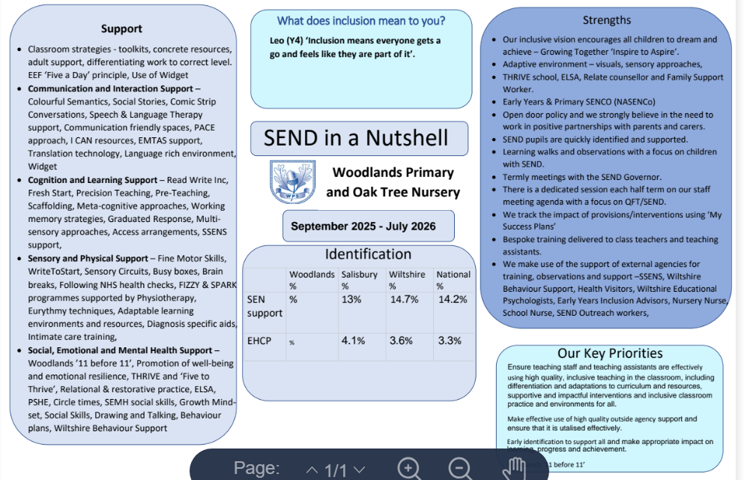
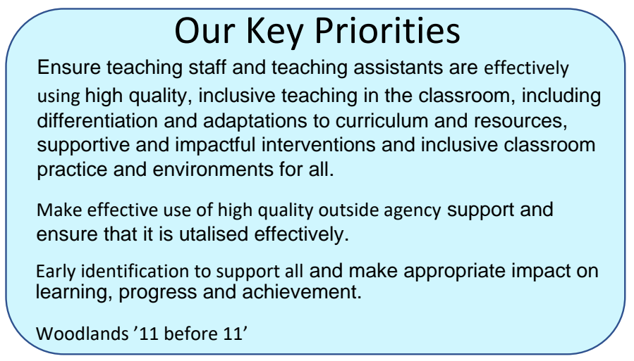

What does inclusion mean to you?
‘People are all different but we can all belong’ Year 6 Pupil
‘We don’t leave anyone out!’ Year 1 Pupil

September 2025 – July 2026
Woodlands Primary and Oak Tree Nursery School
SEND in a Nutshell


IDENTIFICATION

 | WOODLANDS | WILTSHIRE | NATIONAL
SEN SUPPORT | 13.3% | 14.3% | 14.2%
EHCP | 5.7% | 6.2% | 5.3%

