
SEN Information Report 2025-2026

Mrs Helen Hollands (Primary and Early Years SENCO) is responsible for the leading SEND across Woodlands Primary and Oak Tree Nursery School. To find out more about SEND at Woodlands Primary School, browse through the report below, have a look at our SEND Policy or contact Mrs Hollands in person on 01722 335849 or email sen@woodlands.wilts.sch.uk

Aim
“The leadership of provision for pupils with special educational needs and/or disabilities (SEND) is effective. There are clear systems to ensure that the needs of these pupils are identified accurately and the right provision is put in place. Leaders work effectively with external agencies to ensure that pupils receive the support they need.” Ofsted July 2019
‘Woodlands is a highly inclusive school’ Ofsted May 2023.
At Woodlands Primary School we believe in high aspirations, leading to sustained progress and achievement for all children. We aim to meet the needs of individual children through accurate assessment and highly effective teaching and learning. We place a strong emphasis on the early identification of pupil needs and aim to reduce any barriers to learning through supportive and preventative strategies. We undertake a rigorous system of monitoring children’s progress, supporting academic and personal achievement. From this, we endeavour to foster a culture of lifelong learning and independent living skills for all children. We work in a flexible way to develop effective partnerships with all stakeholders, ensuring that the school meets a broad range of special educational needs. Stakeholders include: children and their parents/carers, the Special Educational Needs Coordinator (SENDCO), governors, teaching assistants, specialist teaching staff both within the school and external professionals such as Educational Psychologist, Speech Therapist, SEND advisors and the Wiltshire Council Special Educational Needs team.

Principles
The school follows a graduated approach to inclusion At Woodlands Primary School we know this will look different for each child and many strategies and adaptations might be employed for each child to be successful in order to maximise their progress. Staff continue to adapt teaching to respond to the strengths and needs of all pupils through Quality First Teaching within an inclusive setting.

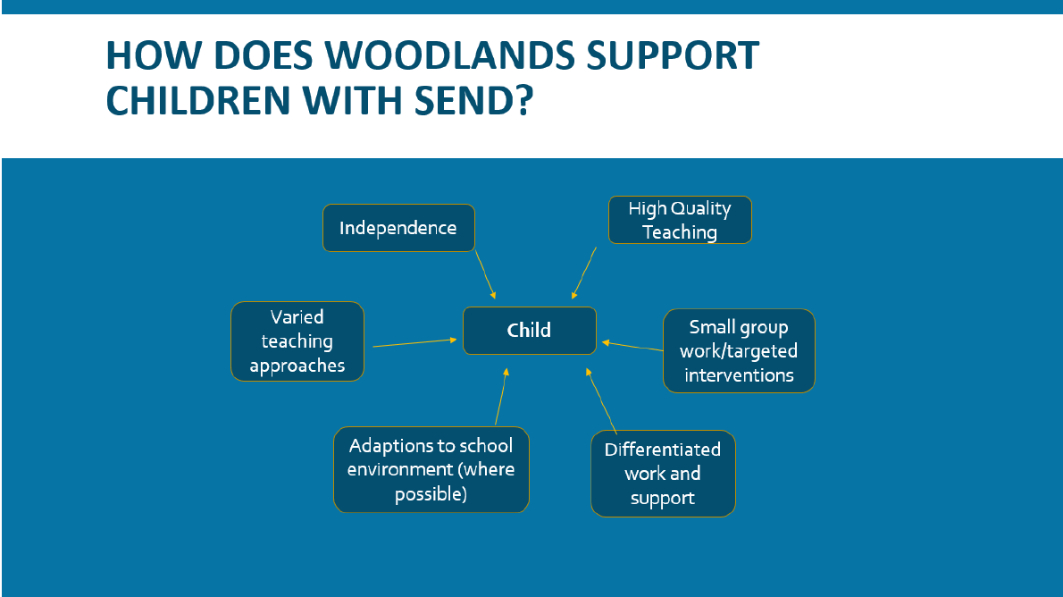

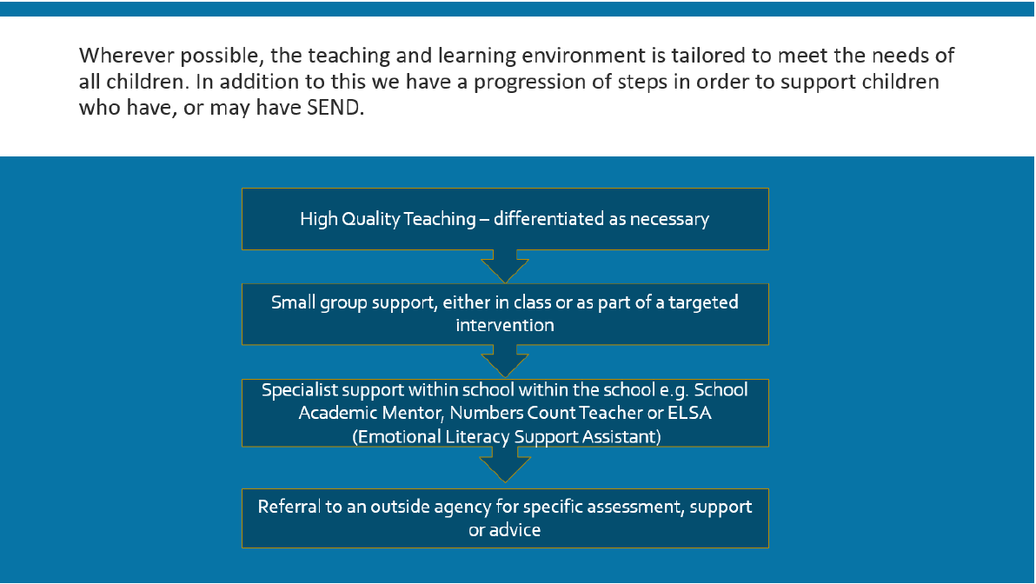

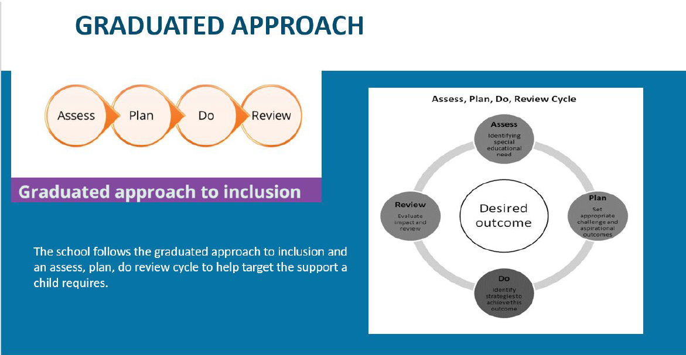

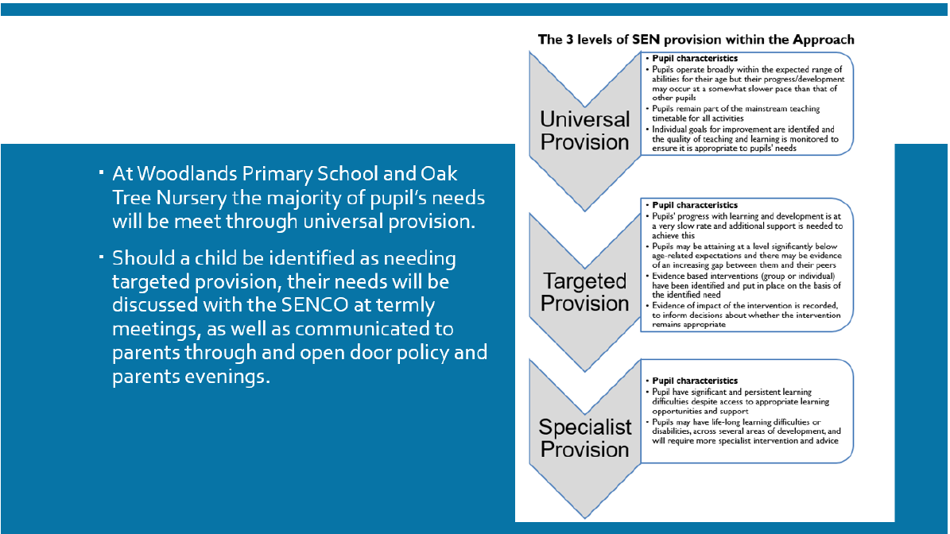

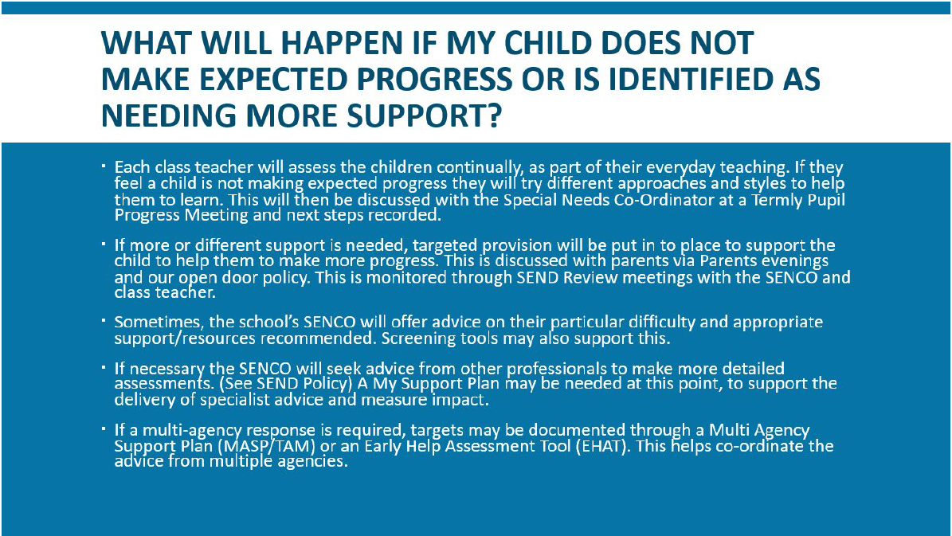

Context and Identifying needs

Quality first teaching means making reasonable adjustments to classroom practice for any pupil and will include good scaffolds for children with specific or less specific need e.g visual timetables, flexible seating arrangements, classroom acoustics, overlays for reading to name just a few. We have reviewed our QFT / SEND document and provision map tracking document and also linked it to our new Pupil Progress tracking documentation.
After a child has been given time to settle in a class if they are not making sufficient progress or there is an on-going concern regarding their behaviour or a sudden change in their emotional well-being the class teacher and SENCO will meet to discuss their needs with the parents. During this meeting they will look at what support they can be offered as well as taking into account the pupil voice and their perception of their learning and behaviour. It is at this point a decision will be made as to whether the child has SEND need or whether there could be another reason for their under-achievement or whether more information needs to be collated. Identification to access support at Local Authority My Support Plan and Education and Health Care Plan (EHCP) levels, will be done through using the Wiltshire Graduated Response to SEND support (GRSS) document and other relevant publications and recommended checklists. Our school will then offer the most relevant intervention or support to help that child achieve their full potential in their learning.

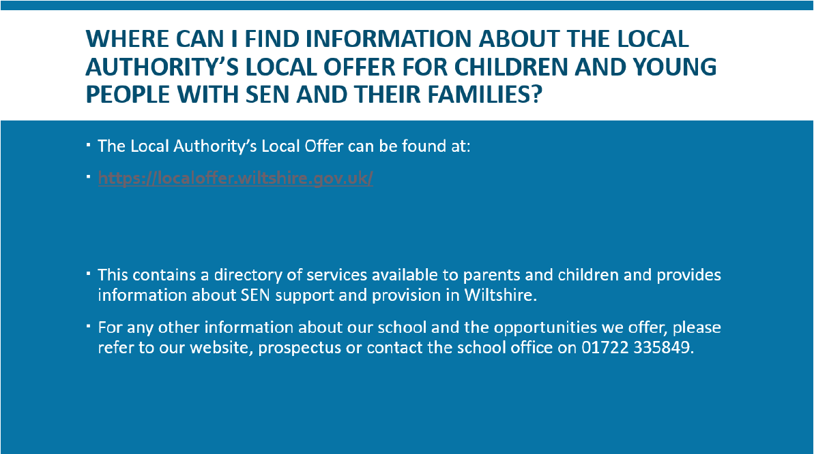

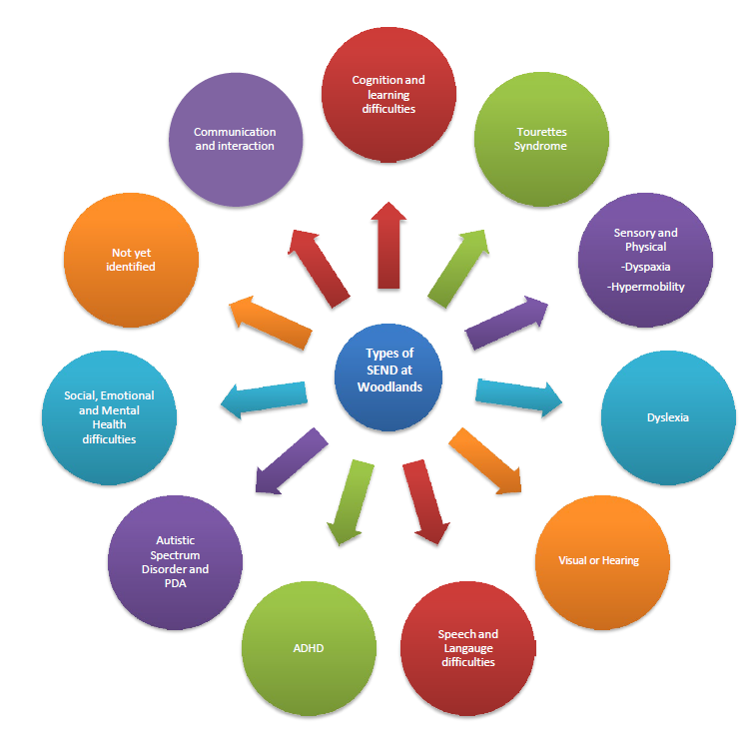
What does SEND look like at Woodlands?

How are pupils identified as possibly having Special Educational Needs (SEND)?

Occasionally, a pupil’s needs are identified before they start school. When this occurs, we liaise closely with the pre- school/nursery setting and the Local Authority to ensure all the relevant information regarding the pupil and their needs has been passed on to enable us to meet their needs successfully. Generally, teachers and parents initially raise concerns that pupils are not making the progress that they were expecting academically and/or socially and emotionally.
Following this, Mrs Hollands along with the class teacher, monitors the pupil’s progress through observations, book scrutiny’, the use of formal assessments in Reading, Spelling and Maths and observations during social/unstructured times. Sometimes a pupil’s doctor may refer them to see other professionals who send a report to school to offer advice and strategies to support the pupil in school.

What would happen if your child was found to have a Special Educational Need?
Here is what happened to Rachel (based on a real pupil at school – name changed) over the past year to explain what has happened to our pupils identified as having SEND.

How much did SEND support help in 2024 – 2025?
Part of Mrs Hollands role is to evaluate provision for children with SEND. They considered what worked well for pupils with SEND, what we need to develop and what additional support we can offer. Below is a breakdown of these areas.

Further increase the number of SEND pupils accessing after-school clubs as part of 11 by 11 Personal Development Offer.

Seeking Dyslexia Friendly Award
Training for teaching staff and assistants
Specific time for teachers to deliver pre-teaching and over learning.
- Additional teaching time for Academic Mentor Anna Kitley to work with SEND pupils to embed key skills in reading.
Enhance adapted provision for foundation subjects.
Interventions based on gap analysis from White Rose Maths and Rising Stars assessments.
English leader, Miss James, is developing the use of the Reading Plus Program for all pupils including those with SEND.
Bespoke SEND provision led by HLTA Mrs Payne for pupils in Y5 and Y6.
The use of Number Stacks as a tool for helping SEND pupils develop their understanding of key maths skills.
To embed the use of THRIVE throughout the school.
To develop our strategies to capture the child’s voice in reviewing their provision.

Quality First teaching in every class. All teachers should develop a repertoire of these strategies they can use flexibly in response to the needs of all pupils.
- Flexible Grouping
- Cognitive and Metacognitive strategies
- Explicit Instruction
- Pre-Teaching
- Using technology to support pupils (eg. WIDGET or voice recognition)
- Scaffolding
TA support covering interventions such as ECAT/BLAST/Talkboost/NELI/Toe by Toe/Speech and Language
Read, Write, Inc Phonics Intervention
Teacher’s knowing their pupils and making sure they plan carefully for them.
Teacher’s receive specific training based on children’s needs.
Send Support Plans to monitor children’s individual targets (3Xs a year) and progress and impact on targeted needs through specific strategies are monitored (X6 a year).
High expectations of children with SEND to develop independence
Numbers Count Maths delivered by specialist teacher – Mrs Cox
Mrs Hollands meeting with other SENCOs within the Salisbury cluster
Dedicated ELSA Room
Trained ELSA (Emotional Literacy Support Assistants) Mrs Giles and Mrs Payne
Strong Partnerships with parents established through frequent meetings and continual dialogue.
Working with outside agencies
Targeted interventions
Dyslexia screener (WESFORD) and provision to support analysis of needs

What worked well and will stay the same in 2025-2026!
Our future plans for SEND at Woodlands!
What we plan to develop in 2025-2026!

Who helps Mrs Hollands help you?
Everyone at Woodlands wants to make school as positive an experience as possible for the pupils and parents. Below are a few friendly people who have had extra knowledge to help us provide successful provision for children with SEND.

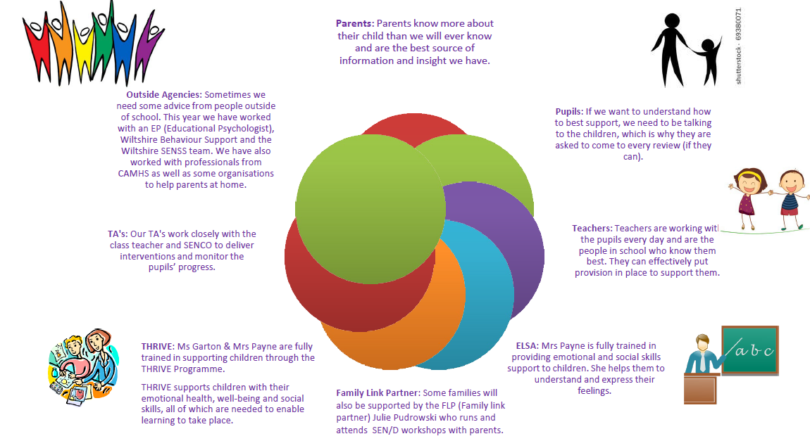

How do we work as a team?
Mrs Hollands cannot do the job of SENCO without being part of a team. Here are just a few times Woodlands staff have collaborated to ensure the correct provision is in place for a child.

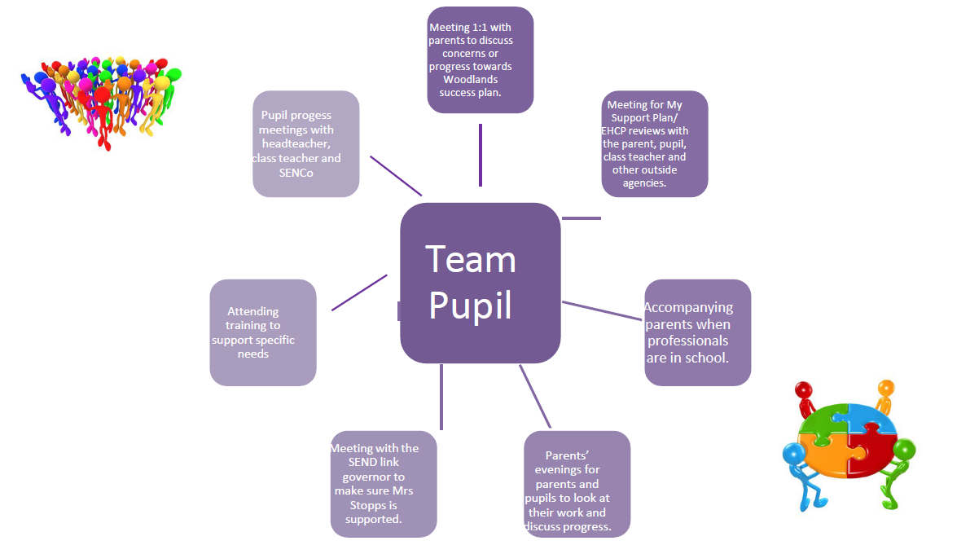
Meeting 1:1 with parents to discuss concerns or progress towards Woodlands My Success Plan
Meeting for SEND Support Plan/EHCP reviews with the parent, pupil, class teacher and other outside agencies/professionals
Pupil Progress meetings with headteacher, class teacher, curriculum leads and SENCO


Collaborating with colleagues across the Salisbury SEND cluster to improve provision for children with SEND
Accompanying parents during meetings with professionals in school and to visit alternative provisions with parents

Parent Support Advisor, THRIVE practitioners and ELSA practitioners supporting meetings with parents and holding SEND coffee mornings and meet and chat sessions
Parents evening’s for parents and pupils to celebrate their child’s learning and progress

Attending SEND training to support specific needs with colleagues across the school and cluster
Meetings with the SEND link governor to make sure Mrs Hollands is supported and challenged to continually improve provision

What else does Mrs Hollands do to help SEND at Woodlands?

What’s next?

This report highlights how inclusion is at the heart of our Woodlands school community. We want every child to know that they belong and will be proactively supported to flourish.

Mrs Hollands is always happy to listen to your comments and observations and answer any questions you may have about the information in this report as we work together to support your child.

School Office: 01722 335849
Email: sen@woodlands.wilts.sch.uk



