Newsletter 1 Tuesday 25th August 2026
We hope that you are having an enjoyable summer holiday. We know, following on from a successful and enjoyable ‘Bump up Day’, that you and your child(ren) are looking forward to a new School Year.

Please find below a reminder of some of our school procedures, to provide clarity for everyone, of the key things to remember for the start of a new academic year.

As ever, if there is anything that we need to know, or anything about which we can provide reassurance or clarity, please don’t hesitate to get into contact by using the details at the top of this letter.

Start of Term
We look forward to welcoming you back to School on Wednesday 2nd September (Oak Tree Nursery & Reception/EYFS2 children start on Thursday 3rd September). Please remember classroom doors open at 8.40am and close at 8.50am. When children are dropped off at School, they should go straight into class. This provides a calm start to the day, and avoids any gathering of groups. There are always adults on the Playground, and adults by the classroom doors, so if you have a message to pass onto the teachers, please let one of them know.

Pick Up
Pick up will be at 3.00pm, using the same doors as drop off. Please try to be prompt to collect your child(ren). If you are picking up more than one child, please collect the youngest sibling first, whilst your other child/ren waits with their class teacher/s.
If you are running late, your child/ren will be taken to the Office. When you arrive, please go directly to the Office. After 3.10pm you will need to pick your child up from the after-school club and you will be charged for the first session (£4.00). Please go directly to the outside hall doors to collect them.

Playground Equipment / Safety – Bike / Scooter Safety
Also a reminder that children (and pre-school children) should not be on or using any of the school playground equipment at the beginning or end of the school day. In addition to this children should not be riding on bikes or scooters when on the school playground. Please can you remind your child to dismount and then walk their bike/scooter in safely into school. We would also ask that you make sure that your child/ren do not bring in their own balls or any other outdoor equipment to use during playtimes.
Children cycling or scooting to school should be wearing a helmet.

Walking home Independently Year 5 and Year 6:
If your child is in Year 5 or 6 you should send an email to the school Office address (admin@woodlands.wilts.sch.uk) with the title "Walking Home Permission" along with your child's name, Year Group and Class in the subject line.
Within the email you should state:
- that you give your permission for your child to Walk or Cycle home at the end of the day;
- which days you give your permission for your child to Walk or Cycle home at the end of the day;
- whether they are to travel alone or with other children.

Please note this is an annual update, so for Year 6 children even if you gave permission last year you will need to do so again for the new school year.
Mobile Phones:
Those children that do walk home independently are permitted to bring a mobile phone into school which they can use on their journey to and from school. Children hand their phones into their Class Teacher.
There are no circumstances where it is acceptable for a child to have their mobile phone with them during the school Day.
The children must switch their phones off on arrival at the school gate and they can be switched back on again once they have left the school premises at the end of the day.

Being picked up by other adults:
To allow your child to be picked up by an adult other than one with parental responsibility, (including when they might be having a playdate) you should send an email to the school Office address with ‘Going Home’ in the subject box. Within the email you should state:
- that you give your permission for your child to be collected at the end of the day;
- the names and contact details of the adults to whom you are permitting the school to release your child/ren to at the end of the day;
- which days you give your permission for your child to be collected at the end of the day.

Uniform:
It is important that all children wear the correct school uniform, and they should wear their school uniform with pride – it is part of our identity as a school, and children should be encouraged to be proud of themselves and their school at all times. We have high expectations of how children present themselves and we will be ensuring in September that the children wear the correct uniform.
The Woodlands Primary School PE hoodie should be worn on PE days. New pupils will be given a voucher to enable you to buy a new PE hoodie.

Boys: Grey trousers or shorts, white shirt/polo shirt, school sweatshirt/cardigan, grey socks, black shoes.

Girls: Grey skirt, pinafore dress or trousers, white blouse/polo shirt, school sweatshirt/cardigan, grey or black tights, black shoes. Blue gingham summer dress

Plain black shoes or plain black sandals with heel straps. High heel shoes, boots and shoes above ankle height are not permitted.
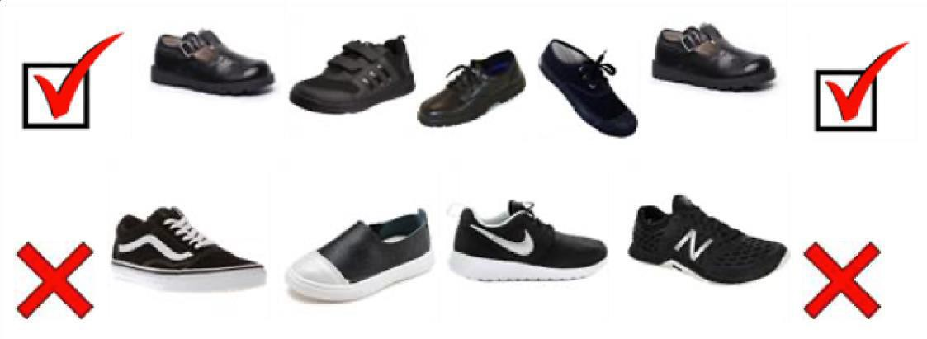

PE T-SHIRTS (one of 4 house colours – no logo) - not needed until Y1 and above. For Acorn class (YR) please provide any colour or design of t-shirt. Please ensure shorts/leggings/joggers are black or blue.

Just to remind you that school uniform can be bought from Skoolkit (formerly Kids Klobber) on 20 Endless Street in the town centre. They stock embroidered jumpers, polo shirts, embroidered cardigans, PE t-shirts, trousers, skirts, pinafores, shorts and summer gingham dresses. They even sell socks and shoes! If you wish to check they have the right size in stock before you head down there please call on 01722 321200.

Can I remind all parents that children should not come to school wearing jewellery. This is for important Health and Safety reasons and also because valuable items can easily be lost and the school is not liable/responsible for any loss. If your child has pierced ears please be aware these will need to be removed for PE lessons or if they are new or unable to be removed please supply a micropore type tape that can be used to cover them. Only stud earrings are allowed not large hooped earrings.

For safeguarding reasons, smart watches that have the facility to message, record and/or video must not be worn in School.

Please also note that nail varnish, temporary tattoos and dyed hair are not part of our school uniform. If your child come into school wearing nail varnish, we will ask for this to be removed by the next day. In addition to this hair that is below the shoulders should be tied up – this is for health and safety reasons and to prevent the spread of head lice.

Finally, it is vital that all clothing items (particularly cardigans, sweatshirts and coats) are clearly (and permanently) named. We cannot easily return un-named items to the correct pupil. All un-named lost property will be held for a week and then put out for general distribution or passed to a charity shop.

PE Days
Following positive pupil feedback, allowing children to have a longer PE session as a result of not having to get changed, children should again this year come in to School in PE Kit on days on which they have PE.
PE will take place from the first day of term onwards.
Days are as follow (all times are pm unless stated otherwise):

EYFS2 | Acorn | Tuesday (am)
Year 1 | Ash | Friday (am)
Year 2 | Cedar | Wednesday
Year 3 | Hazel | Friday
Year 4 | Willow | Thursday
Year 5 | Beech | Monday
Year 6 | Maple | Tuesday

Lunches Update:

We are delighted to announce that from September, Woodlands Primary School will be moving to a new catering provider, Edwards & Ward. Edwards & Ward is an independent catering company specialising in the education sector, with a strong focus on providing children with nutritious, tasty and appealing school meals. We are looking forward to working closely with their team and are excited about the improvements and increased choice they will bring to our school lunch provision. We hope that our children will really enjoy the new menus and the range of meals available.

The new menus will be uploaded and available for parents to view ready for the 1st of September.
Please remember that the Government’s Universal Free School Meal scheme does not extend into Key Stage 2 – so, if your child is moving up ton Year 3, you will not automatically be entitled to Free School Meals or a free snack at break time. If you think you are entitled to Free School Meals, please apply using the link: https://www.wiltshire.gov.uk/schools-learning-free-school-meals
Even if you don’t want your child to have meals every day, or at all, there are benefits to you and the School if you successfully apply for Free School Meals.
Children, who are not having a School Lunch, should take their lunchboxes to their classrooms at the beginning of the School Day.

When preparing School Packed Lunches, please remember we are a nut and nut-product free School PLEASE CHECK THE LABELLING OF ALL PRODUCTS YOU SEND IN VERY CAREFULLY Healthy Snacks:

We encourage all pupils from Year 3 and above to bring in to School a healthy, naturally produced snack, Suggestions include: fresh or dried fruit or vegetables, cheese and plain breads (crackers/ bread sticks). As mentioned above, please remember we are a nut and nut-product-free School. Year 3 children, now that they are in Key Stage 2, no longer receive a free snack during the day.

Please also remember to send your child into school with a filled water bottle.

Attendance:

The Government continues to state that it is the duty of Schools to report all absences to the Education Welfare Service, which will follow its normal processes (including fining persistent absentees).
Don’t forget: Should your child be unwell or unable to come to School please let the School Office know, by telephone or email communication, by 8.50 am each day.
Those children that arrive after 9.00am will be marked as arriving into School late “L” but before the register is completed and those children that arrive after 9.20am will be marked as “U” which is late after the register has been taken and will affect their attendance. Please ensure you leave plenty of time in the mornings for your child/children to arrive into School on time.

Medicines:

You will need to complete a new permission form, if there is any medicine that your child needs to receive – whether that is medicine we already hold for you, or a new prescription. This includes filling in the form for Asthma Medication/Inhalers etc and any ADHD Medication.

A copy of the Administration of Medicine Form is attached herewith and if you need a printed copy please come to the school office.

Staffing Deployment / Who’s Who:

Most of your child/ ren will have had the opportunity to meet their class teacher on Bump up Day. As a reminder the Teachers and Class names for next year are:

Year Group | Class | Teacher(s)
EYFS1 | Oak Tree Nursery | Mrs H Hollands  Mrs K Scott
EYFS2 | Acorn | Ms N Melbourne
Year 1 | Ash | Miss R Singleton
Year 2 | Cedar | Mrs K Wright  Mrs C Sammons
Year 3 | Hazel | Mrs J Roderick

Year 4 | Willow | Mr M Mawdsley
Year 5 | Beech | Mrs S Murtagh
Year 6 | Maple | Miss L James

Finally, we are looking forward to welcoming the children back and getting to know all our new children - each Year Group has engaging and exciting topics prepared for September; there is much to look forward to.

As ever, we thank you for your continued support and if there is anything that we need to know, or anything we can do to help you and your family prepare for September, please contact us.
We look forward to seeing you all again on Wednesday 2nd September and Thursday 3rd September for Nursery and Reception Pupils.

Kind regards

Mr M Kitley Headteacher

